ATTACHMENT B
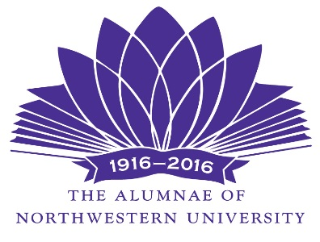

December 1, 2016

To: Deans of Undergraduate and Graduate Schools and Administrators, Northwestern University

From: The Alumnae of Northwestern Grants Committee

Subject: Request for Proposals for Project Funding

Please forward this Request for Proposals to all interested departments and faculty and any Centers associated with your school or position. The proposal due date is February 1, 2017.

The Alumnae of Northwestern University, founded in 1916, is a volunteer organization of 60 active members that serves the University and the community. THIS IS OUR CENTENNIAL YEAR! Since 1931, the Alumnae has given over $8 million dollars to the University. In addition to those projects funded by the Grants program, other contributions have included fellowships, scholarships, and awards to faculty and students as well as special University projects. Alumnae grant funds are raised through its Continuing Education program and the Waa-Mu Show Patron Program.

The Alumnae Grants Committee is issuing this REQUEST FOR PROPOSALS for support of projects not included in the University budget. Most awards are between $1,000 and $6,000, but occasionally larger grant requests also receive funding. The average amount of last year’s grant was $3,788; the highest award was $9,400; the lowest award was $400. Proposals receiving full or partial funding (in no particular priority) have included but are not limited to: specialized equipment purchases, lectures or symposia, innovative curricula and programs, undergraduate research, student projects, and research underwriting and registration for academic conferences. The Alumnae has $125,000 available for this funding opportunity.

Proposals should be no more than two pages in addition to the cover sheet (a copy of which is below) and must include:

• A narrative describing the project
• Start and completion dates/timeline
• A DETAILED line-item budget
• A statement indicating whether partial funding will be acceptable if full funding is not possible and, if applicable, a minimum funding amount required and from where additional funding would be obtained
• A statement describing how a grant from the Alumnae of Northwestern University would be acknowledged or publicized.
• If a student or student group applies, the faculty adviser must sign the proposal; by doing so, he or she indicates his or her willingness to accept responsibility for ensuring proper administration of the grant should it be awarded.

NOTE: PROPOSALS SUBMITTED SHOULD BE WRITTEN FOR THE “EDUCATED LAYPERSON”.

Successful grant applicants will be notified of their award no later than May 1, 2017.

Grant recipients must submit a one-page final report to the Alumnae Grants Committee and to their appropriate Dean/Administrator within six weeks of completion of their project. The report must include:

• how the funds were used
• how the recipient accomplished the goals of the grant
• what impact the grant has had on the recipient(s) program
• how the Alumnae grant was acknowledged or publicized

Projects that cannot be completed as submitted must be given prior additional approval from the Alumnae Grants Committee before proceeding. Unused funds are to be returned to the Alumnae of Northwestern. Funds will be processed through the University’s accounting office and processing the grant shall conform to the University’s policies and procedures. Please note that this grant is not subject to the University’s 4.75% development fee.

Proposal submission information:

• The PROPOSAL DEADLINE is Monday, February 1, 2017. Proposals received after that date must have a postmark on or before January 30, 2017 in order to be considered.

• There will be no extension of the proposal due date.

• Proposals should be sent to:

Margaret G. Eskilson, Chair
Alumnae of NU Grants Committee
3200 Thayer Street
Evanston, IL 60201

• E-mail proposals will NOT be accepted.

- If a proposal is submitted by or for students/graduate students(those considered non-faculty), a faculty sponsor with name and contact information must be included along with the faculty sponsor’s signature

• All proposals will be acknowledged within ten days, If you fail to receive notification, please contact us. You must enable your computer to accept e-mails from MGE3337@AOL.COM

• Questions may be directed to:

Margaret Eskilson MGE3337@AOL.COM or (847) 475-7691

**Request for Proposals forms are also posted at nualumnae.org from the “Gifts to NU” tab**

Attachment (below): Project Proposal Form

ALUMNAE USE ONLY

Proposal#________

Date Received_________
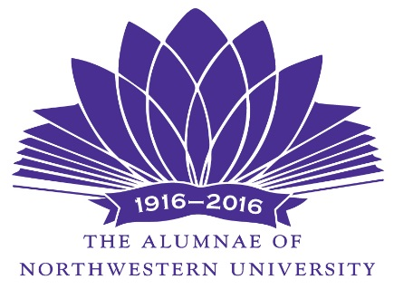

The Alumnae of Northwestern University -2016/2017 Grants Committee

PROJECT PROPOSAL COVER FORM

Due Date: February 1, 2017

Title of Project:

Amount Requested: $ Would partial funding be acceptable? ___Yes ___ No

Minimum $ amount required:

Proposer(s)

Title(s)

School:

Department:

E-mail address: Phone:

Chart String Number for accounting purposes:

If you are a student or student group, please list the name and e-mail address of your faculty adviser:

Faculty adviser signature:
_____________________________________________________

Print Name_________________________________
E-mail address____________________

Please verify that your proposals are consistent with your school’s or office’s policies and procedures.

Please give a brief three sentence or less description summary of your project:

Date project will begin:

Date Project will be complete:

How did you hear about the Alumnae Gifts and Grants program?

_________________________________________________________________________________
(signature of proposer) (date)

Please attach not more than two pages describing this project

Proposals must be received by Feb. 1, 2017 and sent to:

MARGARET G. ESKILSON, Chair
ALUMNAE OF NU GRANTS COMMITTEE
3200 THAYER STREET
EVANSTON, IL 60201

ALL PROPOSALS WILL BE ACKNOWLEDGED; PLEASE CHECK WITH US IF YOU HAVE NOT RECEIVED ONE WITHIN 10 DAYS AFTER SUBMISSION

