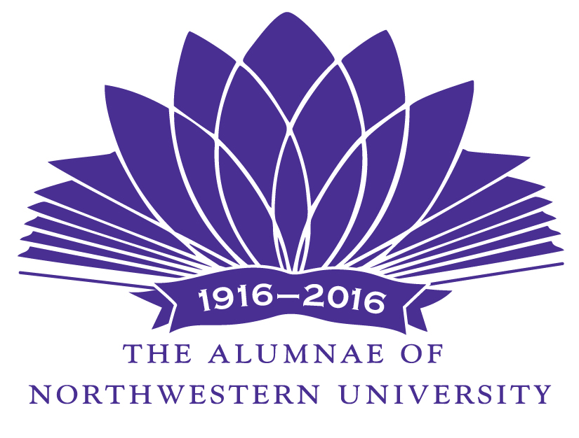
For immediate release
May 2, 2017

For more information:
Michele Bresler, President and Chair, Public Relations
The Alumnae of Northwestern University
847/869-1010 mbresler@sbcglobal.net

The Alumnae of Northwestern University Awards Five Grants for Academic Enrichment

EVANSTON, Ill. --- The Alumnae of Northwestern University has awarded funding for five programs that will bring guest artists and distinguished speakers to Northwestern’s Evanston campus. The grants, totaling more than $25,000, are funded with earnings from the Academic Enrichment Endowment, established in 1991 as one of The Alumnae’s 75th Anniversary gifts to the university.

“The Alumnae takes great pride in its ability to enrich the undergraduate experience by funding these innovative programs, which feature a variety of speakers – journalists, artists, scientists, entrepreneurs, musicians – visiting the Evanston campus,” according to The Alumnae’s Academic Enrichment chair, Carol McMahon.

Principal grants include full or partial funding for:

LISA WOLPE RESIDENCY: SHAKESPEARE AND THE ALCHEMY OF GENDER
Cindy Gold, professor of theater and co-director of Acting for the Screen Module, Theater, School of Communication

Lisa Wolpe, an acknowledged leader in the area of Performance of Gender, will lead a week-long Shakespeare workshop with students and faculty. She will also present her solo piece, “The Alchemy of Gender,” where she performs and contextualizes her experience interpreting some of the many cross-gender roles that she has portrayed.

MAURICE BLANCHOT: ABSENCE OF THOUGHT
Nasrin Qader, associate professor of French and Comparative Literary Studies; chair, Department of French and Italian, Weinberg College of Arts and Sciences (WCAS)

A one-day international symposium on the French thinker and writer, Maurice Blanchot, will bring together renowned scholars from the U.S. and Europe, and will include graduate and advanced undergraduate student participation. The theme of the conference is on the philosophical and literary motif of absence in Blanchot’s thought.

SOUNDSCAPES OF LATINIDAD: RACE, CITIZENSHIP AND BELONGING
Frances R. Aparicio, director, and Veronica Davila, graduate assistant, the Latina and Latino Studies Program, WCAS

A day-long symposium will be dedicated to the scholarly analysis and dialogues about the role of sounds in the struggles for belonging that characterize U.S. Latinx (gender-neutral designation) communities. Six scholars from diverse academic disciplines will convene to discuss issues surrounding expressive cultures, oral traditions, sound technoligies, and others pertaining to the forging of citizenship alternative histories, and ways of belonging.

CONTEMPORARY KOREAN DIASPORA PERFORMANCE; RITUAL MOVEMENT HISTORY AND COMMUNITY
Elizabeth Son, assistant professor, Theater Department, School of Communication

The projecct is an artist residency with performance artist and dancer, Dohee Lee, consisting of a solo performance, workshops, and a final site-specific performance.

MEMORIES OF WAR; KOREA, VIETNAM, CHICAGO
Ji-Yeon Yuh, associate professor of history and Asian American Studies, WCAS

This symposium and exhibit features the oral history research of Northwestern undergraduate students with korean immigrants and Vietnamese refugees in the Chicago area and their memories of war, displacement, and migration. The project includes a one-day conference, a cultural performance, and an exhibit that will travel throughout the Chicago area.

The Alumnae of Northwestern University is an all-volunteer organization of women that raises funds for a wide range of projects to benefit Northwestern while sharing the university’s academic resources with the community through its Continuing Education program. Founded in 1916 and celebrating its Centennial in 2016, The Alumnae has given more than $8 million to the university in the form of grants, fellowships, scholarships, an endowed professorship, and summer internships. For more information, visit The Alumnae website (www.nualumnae.org).

# # #

NR2017 Academic Enrichment/mb

