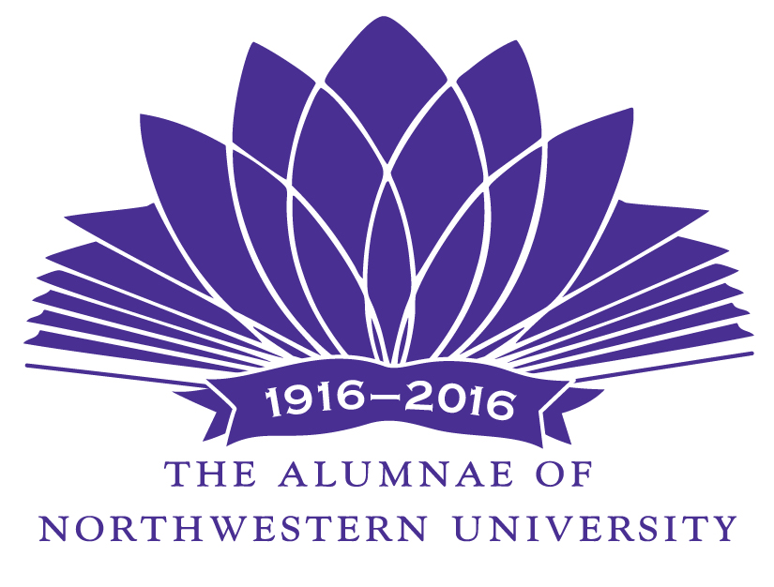
The Alumnae of Northwestern University
January, 2017

To: Northwestern University Provost’s Office
Deans of Undergraduate Schools
Vice-President for Research
Vice-President for Student Affairs

Please distribute this letter to your department chairs and forward to appropriate faculty, as well as any other offices or centers in your organization that might consider submitting a proposal

From: Academic Enrichment Committee of The Alumnae of Northwestern University

The Alumnae of Northwestern University, founded in 1916, is an all-volunteer organization of that serves the University and the community through innovative projects and services. It has given more than $8 million to Northwestern University. In addition to fellowships, scholarships, and awards to faculty and students, awards are also made in the form of grants and special university projects. Many are awarded annually.

Subject: Request for Funding Proposals

The Academic Enrichment Committee is soliciting proposals to bring distinguished scholars and artists to the campus for lectures, master classes and/or performances. The primary goal is to enrich in a significant way the learning experience of undergraduate students; however, these major activities may be open to the entire university community. (Proposals that do not bring scholars or artists to campus to enrich the undergraduate experience may more appropriately fit the guidelines of The Alumnae of Northwestern University’s Grants Program, which issues a separate Request for Proposals.)

The Academic Enrichment grant is funded by an endowment. This year the amount available for award is approximately $25,000. The entire amount is available for one grant; however, in recent years several smaller grants have been awarded.

Proposals must be NO MORE THAN TWO PAGES in addition to the one-page cover sheet (a copy of which is attached and which must be filled out completely), and must include:

• A narrative describing the project;

• An estimate of how many undergraduates would be affected by the proposal and how it would enrich their undergraduate education;

• A line-item budget;

• A statement describing how an award from The Alumnae of Northwestern University would be acknowledged or publicized;

• A statement indicating whether partial funding will be acceptable if full funding is not possible and where additional funds would be obtained.

The successful grant recipient must submit a one-page final report to The Academic Enrichment Committee, with a copy to his/her dean, within six weeks of the completion of the project. The report should describe how the funds were used, how the recipient accomplished the goals of the grant, and what impact the grant had on the recipient’s program. If the project cannot be completed as described within the project time period, the grant recipient must receive prior approval from the Academic Enrichment Committee before proceeding. Processing the grant shall conform to University guidelines and procedures. Unused funds shall be returned to The Alumnae of Northwestern University.

Proposal Deadline:

Proposals must be received by email on or before Wednesday, February 15, 2017. Proposals received after that date will not be considered. Grant awards will be announced by May 1, 2017.

Submit grant proposals to:

Carol McMahon Alumnae Academic Enrichment Chairperson

(calm.one@comcast.net)

Inquiries to Carol McMahon at 847-818-1238 or by email.

Please forward this Request for Proposals to all interested departments and faculty and any centers associated with your school. Though we are unable to fund all requests, we will carefully review each proposal.

See below: Project Proposal Form (must be one page when printed)

For Alumnae Use Only

Date received_________ Proposal Number_______

Alumnae of Northwestern University
2017 Academic Enrichment Committee
PROJECT PROPOSAL

Title of Project: ___________________________________________

Amount Requested: _______Would partial funding be acceptable_____

If partial funding is acceptable, the least amount acceptable: __________

Proposer(s): __________________________________________________

Title: _______________________________________________________

Department: __________________________________________________

Email:__________________________________________________

Brief Description of the project (no more than three sentences):

Date Project will begin: ____________________

Project Completion Date: ____________________

NU Financials Number to be used to transfer monies (if funded): _______________

How did you hear about The Alumnae Academic Enrichment grant program?

Please attach a brief description of this project, not to exceed two pages.
(A curriculum vita is not necessary.)

