Continuing Education
Spring 2014
Aristotle to Einstein: The History of Our Universe
Dr. Michael Smutko

Supplemental Reading:
Some books that might be helpful as background reading for the course are (in alphabetical order):

- Bartusiak, Marcia, The Day We Found the Universe, 2010, ISBN-10: 0307276600
- Kolb, Rocky, Blind Watchers of the Sky: The People and Ideas that Shaped Our View of the Universe, 1997, ISBN-10: 020115496X
- Sagan, Carl, Cosmos, 2013, ISBN-10: 0345539435.
- Singh, Simon, Big Bang: The Origin of the Universe, 2005, ISBN-10: 0007162219
- Weintraub, David, How Old is the Universe?, 2012, ISBN-10: 069115628X

Visiting the Dearborn Observatory:
The Dearborn Observatory is open for public observing with the historic 18.5" Alvan Clark refracting telescope every Friday night from 9:00-11:00 pm in the spring and summer months (8-10 pm in the fall in winter).

The tours at the Dearborn Observatory are open to everyone, and there are two hours open for visiting:
- 9:00 to 10:00pm: Reservation hour. Your group will have a tour of the Observatory, and be able to look through the telescope for the full hour.
- 10:00 to 11:00pm: Walk-ins are welcome. We try to allow everyone at least one opportunity to look through the telescope, but space is limited in the dome; therefore, there is no guarantee that everyone will be able to look through the telescope if we are very crowded.

There is no fee for the Friday night observation tours; however, if you make a reservation for a group of 10 or more, we do require a refundable deposit that will be returned to you on the night of your visit. If you would like to make a reservation or want to learn more about the Observatory, please call the Dearborn Observatory at 847-491-7650. More information can be found online at:
http://ciera.northwestern.edu/observatory.php or https://www.facebook.com/DearbornObservatory

April 15, 2014 – Total Lunar Eclipse!
In the pre-dawn hours of April 15, 2014 (roughly 1:00 am to 4:30 am CDT), a total eclipse of the moon will occur. While binoculars or a small telescope can be helpful, no telescope is required to view this event—just look up! More information can be found here:
http://www.skyandtelescope.com/observing/highlights/April-2014-Total-Lunar-Eclipse-252931091.html

Weather permitting, the Dearborn Observatory will be open for a free public observing event the morning of April 15th. Please check our webpages (see above) or call 847-491-7650 for more information and updates on the eclipse.

Map to the Dearborn
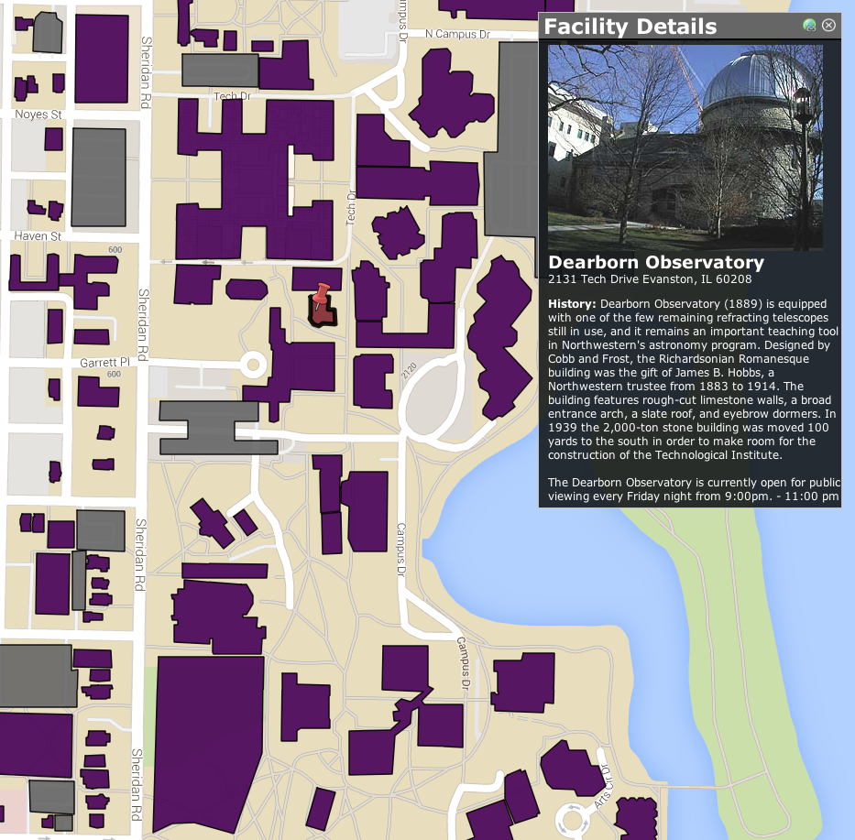
Norris
Tech

